**COVID-19 herd immunity in the Brazilian Amazon**

High SARS-CoV-2 antibody prevalence in blood donors in the Brazilian Amazon

**The herd immunity threshold is the proportion of a population that must be immune to an infectious disease, either by natural infection or vaccination, such that new cases decline in the absence of additional preventative measures**1**. With the recent emergence of COVID-19, this fundamental epidemiological parameter is still unknown and mathematical models have predicted very divergent results**2,3**. Population studies using antibody testing to infer total cumulative infections can provide empirical evidence of herd immunity when conducted in severely affected areas. Here we show that in Manaus, located in the Brazilian Amazon, 52% of the population was infected with SARS-CoV-2 and this coincided with a rapid and sustained drop in COVID-19 mortality. Although the peak of infections may have been reduced by the non-pharmaceutical control measures, this value can be taken as a lower bound on herd immunity threshold for the population of Manaus, a value close to the hypothetical threshold of 60% based on an R0 of 2.5. This result cannot be directly extrapolated to other populations, but does suggest that most countries for which antibody prevalence data has been collected still remain far from reaching natural herd immunity**4**.**

**Main text**

There is no consensus on what proportion of a population must be infected with SARS-CoV-2 before herd immunity is reached. At this threshold new infections decline in the absence of other control measures1. A robust estimate of this quantity can inform all levels of public health policy, including decisions to reopen society and the roll out of vaccination campaigns. Given a basic reproduction number (R0) of 2.5 the theoretical herd immunity threshold for SARS-CoV-2 is 60%, but models that account for heterogenous population mixing predict lower values, ranging from 43%2 to 20%3. This divergence of estimates creates great uncertainty for public health planning.

Antibody prevalence studies employ serology testing to determine the proportion of a population with evidence of prior infection. When conducted in a location thought to have reached herd immunity, this study design can provide empirical evidence of where the true threshold lies. Although there have been numerous antibody prevalence studies in Europe and North America, the low estimates of cumulative infections (generally <20% 5–7) cannot be taken to reflect herd immunity due to the widespread adoption of effective non-pharmaceutical control measures4.

In contrast, Brazil has one of the most rapidly-growing COVID-19 epidemics in the world with the Amazon being the worst hit region8. In Manaus, the capital of Amazonas state, the first case was confirmed on 13th March 20209. The epidemic then exploded and excess mortality in the first week of May was 4.5 times the preceding year10. This was followed by a rapid drop in the number of cases, which have continued to fall despite relaxation of control measures.

Although the ideal design to determine prevalence of SARS-CoV-2 infection is a population-based sample, this approach is time consuming and expensive. Routine blood donations can serve as a logistically-tractable alternative 11–13. Herein, we present cross-sectional monthly seroprevalence estimates in blood donors in Manaus spanning the first seven months of transmission in Brazil and the entire epidemic curve in the Amazon region. We compare these estimates with São Paulo. Our data provide evidence that a lower bound of the herd immunity threshold in Manaus was >50% of the population.

**SARS-CoV-2 antibody dynamics and serology assay validation**

In this study we used a commercially available chemiluminescence assay (CIMA) that detects IgG antibody against the SARS-CoV-2 nucleocapsid protein (Abbott, Chicago, USA). To infer the true prevalence of infections from antibody prevalence the sensitivity and specificity of the antibody test need to be accounted for14. The specificity of the Abbott SARS-CoV-2 CIMA has consistently been shown to be high (>99.0%)7,15,16. However, the high sensitivity (>90.0%)7,16 evidenced in previous validation studies based on severe COVID-19 cases may not apply to blood donor screening17,18 for two reasons. Firstly, most SARS-CoV-2 infections in blood donors are asymptomatic. The weaker antibody response in asymptomatic disease19 may lead to a lower initial seroconversion rate. Second, due to antibody waning the sensitivity falls over time after infection20. As the case mix varies through the course of an epidemic – proportionally more recent cases at the start with increasingly remote cases through time – the sensitivity will drop as a result of seroreversion.

We used a variety of clinical samples at different time points to gain insight into the dynamics of the anti-N IgG detected by the Abbott CIMA (Figure 1). In COVID-19 hospitalized patients at 20-33 days post symptom onset, the sensitivity was 91.8% (95%CI 80.8% to 96.8%), reflecting high disease severity and optimal timing of blood collection. Among a cohort of symptomatic cases with mild disease also tested in the early convalescent period, the sensitivity fell to 84.5% (95%CI 78.7% to 88.9%), and in samples drawn later (50-131 days) the sensitivity was even lower (80.4%, 95%CI 71.8% to 86.8%). Indeed, in a subset of 104 patients with two consecutive blood draws, the signal-to-cutoff (S/C) clearly declined over the period observed (Fig 1B) and among 88 individuals with a positive reading at the first time point, the mean rate of decay was -0.9 log2 S/C units every 100 days (95%CI -1.1 to -0.75), equating to a half-life of 106 days (95%CI 89 to 132 days) (Figure 1C).

Finally, we tested 1,000 blood donations made in São Paulo in July 2020 (pre-test probability of prior infection >12%) in parallel using a second high-specificity (>99.0%) immunoassay (Roche Elecsys, Rotkreuz, Switzerland). One-hundred and three samples were positive on the Abbott CIMA and an additional 30 on the second assay. Assuming all 133 samples were true positives the sensitivity was 77.4% (95%CI 69.6% to 83.7%). The Roche assay detects total Ig and the signal is more stable than the Abbott assay. As samples in July were donated four months into the on-going epidemic in São Paulo, the false negatives contain both cases that did not initially seroconvert, as well as remote infections with subsequent seroreversion.

Because the specificity was high, with only one false-positive result in 821 pre-epidemic donations from Manaus, we also assessed assay performance reducing the threshold for a positive result from 1.4 S/C (as per the manufacturer) to 0.4 S/C. The 27 false-positives resulted in a specificity of 96.7%. The sensitivities at this threshold are shown in Table S1.

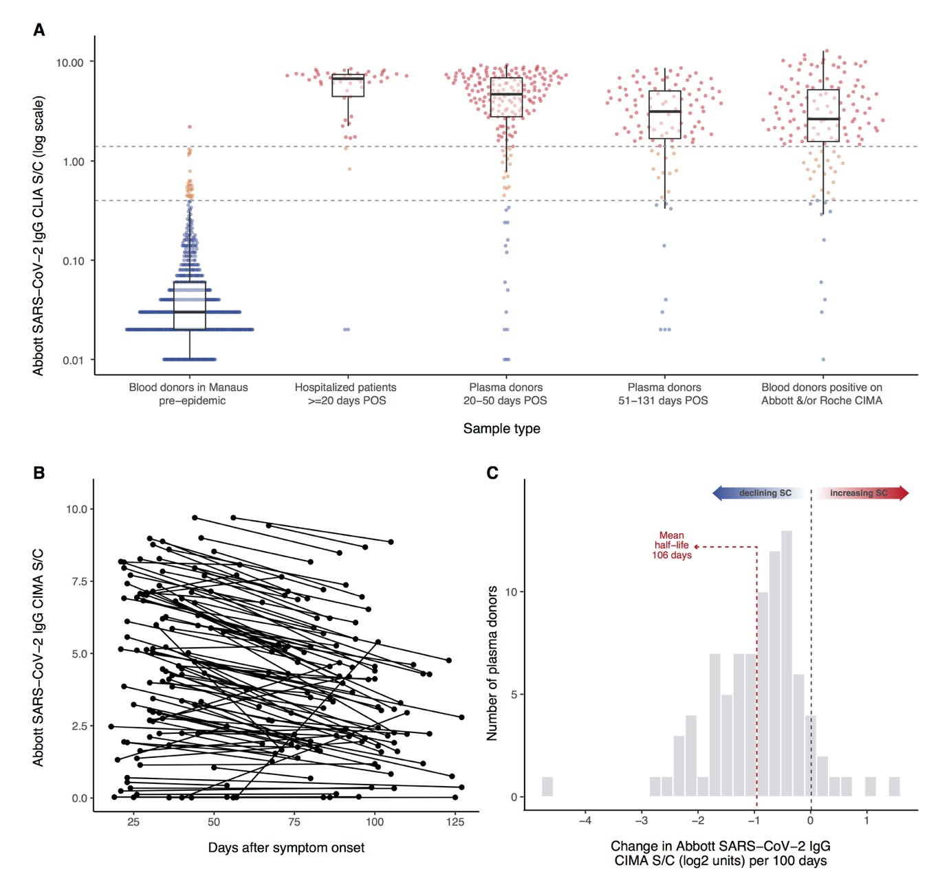

**Figure 1 Abbott SARS-CoV-2 IgG chemiluminescence assay performance and antibody dynamics in different clinical samples.** Panel A shows signal-to-cutoff (S/C) values on the Abbott chemiluminescence assay (CIMA) in the following clinical samples (from left to right): 821 routine blood donation samples made in Manaus in February, more than 1 month prior to the first case notified in the city; 49 SARS-CoV-2-PCR positive patients requiring hospital care; 193 patients with PCR-confirmed symptomatic COVID-19 not requiring hospital care, samples taken in the early convalescent period; 107 samples taken in the same cohort the late convalescent period; 133 samples testing positive on either the Abbott CIMA or the Roche Elecsys assay out of 1,000 routine blood donations tested in parallel from the Fundação Pró-Sangue blood centre (São Paulo) collected in July 2020. Upper dashed line - manufacturer’s threshold for positive result of 1.4 S/C; lower dashed line - alternative threshold of 0.4 S/C. Panels B - 104 convalescent plasma donors with two blood draws for serology testing on the Abbott CIMA. Panel C histogram of the slopes among 88 individuals shown in panel B that tested positive (>1.4 S/C) at the first time point. POS – post symptom onset.

**Prevalence of SARS-CoV-2 antibodies in Manaus and São Paulo**

In order to estimate the proportion of the population with antibodies against SARS-CoV-2, we used a convenience sample of routine blood donations made at the Fundação Pró-Sangue blood bank in São Paulo and the Fundação Hospitalar de Hematologia e Hemoterapia do Amazonas (HEMOAM) in Manaus. We selected donations between the dates shown in Table 1 for the months of February

through August 2020. See methods for the sample selection procedure. The number of monthly samples tested and the number of positive results are shown in Table 1.

|  |  |  |  |  |  |  |  |  |  |  |  |
| --- | --- | --- | --- | --- | --- | --- | --- | --- | --- | --- | --- |
| **Location and sampling dates** | **Total samples tested** | **1.4 S/C threshold to define positive result** | | | | **0.4 S/C threshold to define positive result** | | | | | |
| **Positive samples** | **Crude prevalence %**  **(95% CI)** | **Weighted prevalence (95% CI)** | **Sens/spec adjusted prevalence**  **(95% CI)** | **Positive samples** | **Crude prevalence %**  **(95% CI)** | **Weighted prevalence %**  **(95% CI)** | **Sens/spec adjusted prevalence %**  **(95% CI)** | **Seropreversion adjusted prevalence**  **Min decay rate**  **(95%CI)** | **Seropreversion adjusted prevalence**  **Death calibration**  **(95%CI)** |
| **Manaus**  Feb 7th-13th  Mar 6th-12th  Apr 6th-17th  May 5th-14th  Jun 5th-15th  Jul 6th-15th  Aug 8th-19th | 821  831  829  900  909  1145  881 | 1  6  46  359  421  418  242 | 0.1 (0.0-0.7)  0.7 (0.3-1.6)  5.5 (4.1- 7.3)  39.9 (36.7-43.2)  46.3 (43.0-49.6)  36.5 (33.7-39.4)  27.5 (24.5-30.5) | 0.4 (0.0-2.2)  0.7 (0.2-1.8)  4.1 (2.8-5.8)  37.4 (33.0-42.0)  43.8 (39.6-48.0)  33.9 (30.0-37.9)  25.5 (22.2-29.1) | 0.3 (0.0-2.4)  0.7 (0.1-2.0)  4.8 (3.3-6.8)  44.2 (39.0-49.7)  51.8 (46.8-56.8)  40.0 (35.5-44.8)  30.1 (26.2-34.3) | 27  25  84  413  494  580  426 | 3.3 (2.2-4.7)  3.0 (2.0- 4.4)  10.1 (8.2-12.4)  45.9 (42.6-49.2)  54.3 (51.0-57.6)  50.7 (47.7-53.6)  48.4 (45.0-51.7) | 3.7 (2.0-6.3)  2.6 (1.6- 4.1)  7.7 (5.9-9.9)  42.1 (37.6-46.7)  52.5 (48.2-56.7)  46.9 (42.7-51.1)  44.0 (40.0-48.0) | 0.4 (0.0-3.3)  0.0 (0.0-0.9)  5.0 (2.9-7.4)  43.6 (38.5-48.8)  55.3 (50.5-60.1)  49.0 (44.3-53.8)  45.7 (41.3-50.2) | -  0.0 (0.0-0.0)  3.0 (1.6-5.1)  38.1 (33.0-42.8)  59.5 (54.1-64.3)  64.6 (56.2-72.5)  64.6 (56.4-72.3) | -  0.0 (0.0-0.0)  5.0 (3.0-7.9)  38.0 (34.7-41.7)  63.9 (59.0-69.4)  70.9 (65.6-76.9)  74.6 (69.0-80.8) |
| **São Paulo**  Feb 8th-29th  Mar 9th-21st  Apr 8th-30th  May 8th-21st  Jun 8th-20th  Jul 13th-25th  Aug 10th-21st | 799  2454  900  826  880  879  813 | 7  22  27  44  105  84  98 | 0.9 (0.4-1.8)  0.9 (0.6-1.4)  3.0 (2.0-4.3)  5.3 (3.9-7.1)  11. 9 (9.9-14.3)  9.6 (7.7-11.7)  12.1 (9.9- 13.3) | 0.9 (0.3-1.9)  0.8 (0.5-1.2)  2.6 (1.6-3.9)  5.1 (3.4-7.2)  11.6 (9.3-14.1)  9.5 (7.6-11.8)  11.6 (9.2-14.3) | 1.0 (0.3-2.1)  0.8 (0.5-1.3)  2.9 (1.7-4.5)  5.9 (4.3-9.2)  13.6 (12.0-18.1)  11.2 (8.8-13.9)  13.6 (10.8 -16.8) | 36  149  58  69  145  116  149 | 4.5 (3.2-6.2)  6.1 (5.2-7.1)  6.4 (4.9-8.3)  8.4 (6.6-10.5)  15.3 (13.0-17.9)  13.2 (11.1-15.6)  18.3 (15.7-21.2) | 4.2 (2.9-6.0)  5.8 (4.9-6.8)  6.8 (4.9-9.1)  7.5 (5.6-9.8)  14.9 (12.5-17.8)  12.8 (10.5-15.3)  16.7 (13.9-19.6.2) | 1.0 (0.0-2.9)  2.8 (1.8-3.9)  4.0 (1.8-6.6)  4.8 (2.6-7.4)  13.2 (10.3-16.3)  10.7 (8.1-13.5)  15.1 (12.0.-18.5) | -  0.0 (0.0-0.0)  1.7 (0.6-3.0)  5.0 (3.3-7.3)  13.1 (10.5-16.2)  15.2 (12.6-18.2)  19.7 (16.4-23.4) | -  0.3 (0.0-0.5)  2.0 (1.4-3.7)  7.3 (5.4-9.5)  13.2 (8.4-16.9)  17.9 (10.4-23.5)  21.3 (12.1-28.2) |

**Table 1. Results of cross-sectional samples of blood donors in Manaus and São Paulo.** Weighted prevalence was calculated by applying weights proportional to the projected age-sex population structure of Manaus and São Paulo within the age group eligible to donate blood. Further adjustment for sensitivity and specificity was performed with the Rogan and Gladen method 25,26 to give the adjusted prevalence. At the 1.4 S/C threshold the sensitivity and specificity were taken to be 84.% and 99.9%, respectively; at the 0.4 threshold they were taken to be 92.2% and 96.7%, respectively (see Table S1). See methods for details of adjustment for seroreversion.

Table 1 presents the crude monthly antibody prevalence among blood donors; the prevalence re-weighted to the age-sex distribution of each city; and the prevalence following adjustment for test performance, calculated both at the manufacture’s threshold (1.4 S/C) and the reduced threshold (0.4 S/C). Sensitivity adjustments were based on the early-phase convalescent plasma donors (Figure 1A), as these estimates account for initial non-seroconversion before significant antibody waning. We then formally account for antibody waning using a simple model-based approach (see Methods and Table 1).

We find that the prevalence of SARS-CoV-2 antibodies in February and March was low (<1%) in both São Paulo and Manaus. This is consistent with the timing of the first confirmed cases which were diagnosed on 13th March in Manaus, and in São Paulo on 25th February9.

In Manaus, after adjustment for the sensitivity and specificity of the test and re-weighting for demographics, the prevalence of SARS-CoV-2 IgG antibody was 4.8 (95%CI 3.3%-6.8%) in April, 44.2% (95%CI 39.0%-49.7%) in May, reaching a peak of 51.8% (46.8%-56.8%) in June. The changing prevalence closely followed the of curve of cumulative deaths. In São Paulo the prevalence of SARS-CoV-2 IgG in blood donors also increased steadily, reaching 13.6% (12.0%-18.1%)

in June.

Between June and August, the effect of seroreversion became apparent in both cities. In Manaus, following the peak antibody prevalence in June, the proportion of blood donors testing positive fell by 21.2% in July, and 40.6% by August. Excluding extreme negative samples (<0.4 S/C), the median assay signal fell steadily from May onwards: 3.9 (May), 3.5 (June), 2.3 (July) and 1.7 (August), see Figure 2B. The proportion of samples with S/C values just below the manufacturer’s cutoff (0.4 to 1.4 S/C) increased over this period: 6.0% (May), 8.0% (Jun), 14.1% (Jul) and 20.0% (Aug). Similarly, in São Paulo the antibody prevalence remained stable between June and August, while the number of daily COVID-19 deaths remained relatively stable (Figure 2C).

In Manaus, the effect of antibody waning on apparent prevalence was partially ameliorated by reducing the threshold for a positive result from 1.4 S/C to 0.4 S/C and correcting for the resultant increased false-positive rate. However, the results in São Paulo were largely unchanged by this correction (Figure 2 and Table 1).

We further correct for seroreversion with a model-based approach (see Methods for details). Briefly, we assume that the probability of remaining seropositive decays exponentially from the time of recovery. We estimate the decay rate and the proportion of patients that serorevert using the seroprevalence data from Manaus to find the minimum decay rate that avoids drops in seroprevalence, which is equivalent to assuming there were no cases in Manaus in July and August and any change in seroprevalence was due only to waning antibodies. The results of these corrections are shown in Table 1 and Figure 2. We find that after adjusting for seroreversion, the cumulative incidence of infections in Manaus may have reached a value as high as 66.1% (95%CI 60.8%-79.9%). But in the absence of an accepted approach to account for seroreversion, these results should be interpreted with caution.

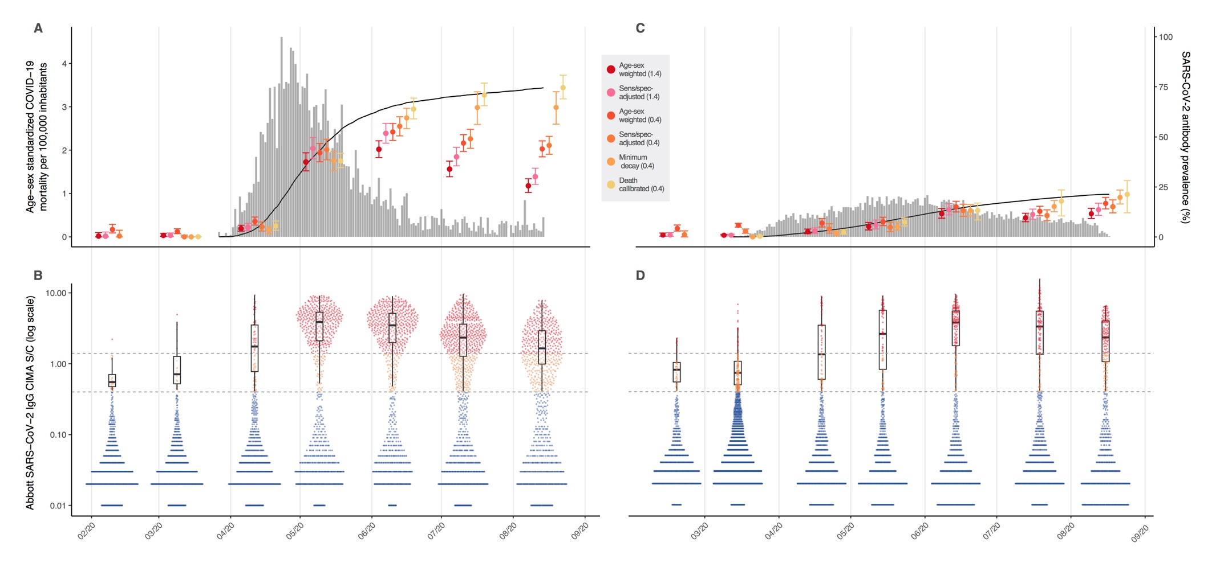

**Figure 2 Monthly antibody prevalence and signal-to-cutoff (S/C) reading in Manaus and São Paulo.** SARS-CoV-2 antibody prevalence estimates in Manaus (A) and São Paulo (C) with a range of corrections. Error bars are 95% confidence intervals. Grey bars are standardized daily mortality using confirmed COVID-19 deaths in the SIVEP-Gripe (https://covid.saude.gov.br/) notification system and standardized by the direct method using the total projected Brazilian population for 2020 as the reference. Black lines are the cumulative deaths rescaled so that the maximum is set to the maximum seroprevalence estimate for each city. Distribution of S/C values over the seven monthly samples are shown for Manaus (B) and São Paulo (D). Each point represents the S/C reading for a single donation sample. Upper dashed line - manufacturer’s threshold (1.4 S/C units); lower dashed line - alternative threshold (0.4 S/C units); black boxplots show the median, interquartile range and range of S/C values above 0.4 (i.e. excluding very low and likely true-negative values).

**Infection fatality ratio in Manaus**

Considering an antibody prevalence of 51.8%, two months following the epidemic peak in Manaus, we estimate that 1,147,089 cumulative infections to have occurred. By 15th June, 1,937 confirmed COVID-19 deaths had been reported, equating to an infection fatality ratio of 0.17%. Considering all severe acute respiratory syndrome deaths (due to COVID-19 or unknown cause), the cumulative number of deaths was 3,175 with a resulting infection fatality ratio of 0.28%.

**Discussion**

Our data show that over half the population in Manaus was infected with SARS-CoV-2 during the course of the epidemic. The extremely elevated mortality and the rapid and sustained drop in cases suggests that the population of Manaus may have quickly reached herd immunity when around 52% of the population was infected, similar to the 60% threshold based the classical calculation using an R0 ~2.5. This result should be interpreted cautiously. It cannot be extrapolated directly to other contexts due to differences in population mixing, vulnerability to infection, as well as implementation and adherence to non-pharmaceutical measures. The proportion of the population with immunity to SARS-CoV-2 works in tandem with these factors to tip the effective reproduction number below unity. Furthermore, given the delay between infection and the humoral response, a lag would be expected between new infections and the slowing of transmission. Considering the rapid growth phase of the epidemic in Manaus, the cumulative infections may have overshot the herd immunity threshold, leading to an overestimate of this quantity.

The non-pharmacological interventions implemented in the city of Manaus (Table S3) were similar to other cities in Brazil including São Paulo. They were implemented in late March before the epidemic took off. Furthermore, cell phone mobility data showed a marked increase in physical distancing beginning in mid-March, with a similar pattern overtime to São Paulo (Figure S4). Therefore, it remains unclear what accounted for such rapid transmission of SARS-CoV-2 in Manaus. Possible explanations include reliance on high risk boat travel in the Amazon region8 in which over-crowding results in accelerated contagion, similar to that seen on cruise ships 27. Household crowding and a young mobile population, as well as the circulation of multiple virus lineages introduced from multiple locations9 may have contributed. It is, however, difficult to explain the rapid and sustained decline in cases without evoking the concept of population immunity, and the high seroprevalence further supports this notion.

We observed a waning of antibodies following the epidemic peak in Manaus. Although this was anticipated given the downwards trend in assay signal in our plasma donors with longitudinal measurements (Fig 1B and 1C), the rate at which donors became negative on the test (40% between May and August) was higher than expected based on this cohort. This probably reflects lower peak antibody level and faster decay in asymptomatic blood donors than individuals with symptomatic disease 21,22. In another cohort of patients with symptomatic COVID-19, the trend in assay signal over approximately 100 days from acute infection was not consistent between assays20. Out of four commercially available high-throughput kits, the Abbott CIMA showed the greatest decline in signal, whereas the Roche assay detected an increasing signal over this period20.

Together with our results these findings have significant consequences for the design and interpretation of antibody prevalence studies. For the purpose of estimating total cumulative infections in a population, the assay chosen should ideally detect a long-lasting component of the humoral response to SARS-CoV-2. Although other assays such as the Roche seem promising in this regard, caution is required before extrapolating data from symptomatic patient cohorts 20 to population surveys, as most infections are asymptomatic in this use case. Despite this limitation of the Abbott assay, one potential advantage to the decay in signal over time is to monitor reinfection at population levels in the case of a second epidemic wave. Indeed, Manaus may act as a sentinel to determine the longevity of population immunity, and an additional strategy to antibody surveillance would be monitoring of local versus imported cases, with an increase suggesting waning population immunity.

Another important limitation is the extent to which blood donors are representative of the wider population with respect to SARS-CoV-2 exposure. Firstly, children and the elderly are excluded from blood donation. Within the eligible age range (16 - 69yr) the age and sex distributions were different from the underlying population in both cities (Figure S1 and S2); however, we attempted to account for this by re-weighting according to age and sex. Furthermore, only healthy asymptomatic adults without a known history of COVID-19 infection are eligible to donate blood. This would be expected to lead to an underestimate of true prevalence – the healthy volunteer effect.

It is reassuring that a household survey in São Paulo city, employing a random sampling strategy and comparable antibody assay, found very similar results: 4.7% seroprevalence in May 28 (5.3% in blood donors) and 11.4% in June (11.9% in blood donors) (<https://www.monitoramentocovid19.org/>). However, in another population-based serosurvey conducted in mid-May in Manaus8, the SARS-CoV-2 seroprevalence was found to be 12.5%, less than half the prevalence at this time point (5th to 14th) among blood donors. This discrepancy is likely accounted for by the fact a lower sensitivity assay was used to test capillary (finger prick) blood. Although the authors corrected for test characteristics, it is likely that the true sensitivity in capillary blood is lower 29. This highlights the advantage of using the blood donor population, where the infrastructure necessary for the use of state of art serological assays is well established. Furthermore, if serological assays are developed that correlate with immunity, blood donors may serve to monitor such markers and facilitate surveillance in areas of the globe where population studies are too expensive to maintain.

**References**

1. Fine, P., Eames, K. & Heymann, D. L. ‘Herd Immunity’: A Rough Guide. *Clinical Infectious Diseases* **52**, 911–916 (2011).

2. Britton, T., Ball, F. & Trapman, P. A mathematical model reveals the influence of population heterogeneity on herd immunity to SARS-CoV-2. *Science* eabc6810 (2020) doi:10.1126/science.abc6810.

3. Aguas, R. *et al.* *Herd immunity thresholds for SARS-CoV-2 estimated from unfolding epidemics*. http://medrxiv.org/lookup/doi/10.1101/2020.07.23.20160762 (2020) doi:10.1101/2020.07.23.20160762.

4. Okell, L. C. *et al.* Have deaths from COVID-19 in Europe plateaued due to herd immunity? *The Lancet* **395**, e110–e111 (2020).

5. Pollán, M. *et al.* Prevalence of SARS-CoV-2 in Spain (ENE-COVID): a nationwide, population-based seroepidemiological study. *The Lancet* **396**, 535–544 (2020).

6. Stringhini, S. *et al.* Seroprevalence of anti-SARS-CoV-2 IgG antibodies in Geneva, Switzerland (SEROCoV-POP): a population-based study. *The Lancet* S0140673620313040 (2020) doi:10.1016/S0140-6736(20)31304-0.

7. Bryan, A. *et al.* Performance Characteristics of the Abbott Architect SARS-CoV-2 IgG Assay and Seroprevalence in Boise, Idaho. *J Clin Microbiol* **58**, e00941-20, /jcm/58/8/JCM.00941-20.atom (2020).

8. Hallal, P. *et al.* *Remarkable variability in SARS-CoV-2 antibodies across Brazilian regions: nationwide serological household survey in 27 states*. http://medrxiv.org/lookup/doi/10.1101/2020.05.30.20117531 (2020) doi:10.1101/2020.05.30.20117531.

9. Candido, D. S. *et al.* Evolution and epidemic spread of SARS-CoV-2 in Brazil. *Science* eabd2161 (2020) doi:10.1126/science.abd2161.

10. Orellana, J. D. Y., Cunha, G. M. da, Marrero, L., Horta, B. L. & Leite, I. da C. Explosão da mortalidade no epicentro amazônico da epidemia de COVID-19. *Cad. Saúde Pública* **36**, e00120020 (2020).

11. Filho, L. A. & Szwarcwald, C. L. Seroprevalence of anti-SARS-CoV-2 among blood donors in Rio de Janeiro, Brazil. 10.

12. Erikstrup, C. *et al.* Estimation of SARS-CoV-2 infection fatality rate by real-time antibody screening of blood donors. *Clinical Infectious Diseases* **ciaa849**,.

13. Thompson, C. P. *et al.* *Detection of neutralising antibodies to SARS coronavirus 2 to determine population exposure in Scottish blood donors between March and May 2020*. http://medrxiv.org/lookup/doi/10.1101/2020.04.13.20060467 (2020) doi:10.1101/2020.04.13.20060467.

14. Lewis, F. I. & Torgerson, P. R. A tutorial in estimating the prevalence of disease in humans and animals in the absence of a gold standard diagnostic. *Emerg Themes Epidemiol* **9**, 9 (2012).

15. Evaluation of Abbott SARS-CoV-2 IgG assay for the detection of anti-SARS-CoV-2 antibodies.

16. Ng, D. *et al.* *SARS-CoV-2 seroprevalence and neutralizing activity in donor and patient blood from the San Francisco Bay Area*. http://medrxiv.org/lookup/doi/10.1101/2020.05.19.20107482 (2020) doi:10.1101/2020.05.19.20107482.

17. Eyre, D. W. *et al.* *Stringent thresholds for SARS-CoV-2 IgG assays result in under-detection of cases reporting loss of taste/smell*. http://medrxiv.org/lookup/doi/10.1101/2020.07.21.20159038 (2020) doi:10.1101/2020.07.21.20159038.

18. Hamilton, F. *et al.* *Kinetics and performance of the Abbott Architect SARS-CoV-2 IgG antibody assay*. http://medrxiv.org/lookup/doi/10.1101/2020.07.03.20145722 (2020) doi:10.1101/2020.07.03.20145722.

19. Long, Q.-X. *et al.* Clinical and immunological assessment of asymptomatic SARS-CoV-2 infections. *Nat Med* (2020) doi:10.1038/s41591-020-0965-6.

20. Muecksch, F. *et al.* *Longitudinal analysis of clinical serology assay performance and neutralising antibody levels in COVID19 convalescents*. http://medrxiv.org/lookup/doi/10.1101/2020.08.05.20169128 (2020) doi:10.1101/2020.08.05.20169128.

21. Carsetti, R. *et al.* *Spectrum of innate and adaptive immune response to SARS CoV 2 infection across asymptomatic, mild and severe cases; a longitudinal cohort study*. http://medrxiv.org/lookup/doi/10.1101/2020.06.22.20137141 (2020) doi:10.1101/2020.06.22.20137141.

22. Seow, J. *et al.* *Longitudinal evaluation and decline of antibody responses in SARS-CoV-2 infection*. http://medrxiv.org/lookup/doi/10.1101/2020.07.09.20148429 (2020) doi:10.1101/2020.07.09.20148429.

23. Callow, K. A., Parry, H. F., Sergeant, M. & Tyrrell, D. A. J. The time course of the immune response to experimental coronavirus infection of man. *Epidemiol. Infect.* **105**, 435–446 (1990).

24. Edridge, A. W. *et al.* *Coronavirus protective immunity is short-lasting*. http://medrxiv.org/lookup/doi/10.1101/2020.05.11.20086439 (2020) doi:10.1101/2020.05.11.20086439.

25. Diggle, P. J. Estimating Prevalence Using an Imperfect Test. *Epidemiology Research International* **2011**, 1–5 (2011).

26. Rogan, W. J. & Gladen, B. Estimating prevalence from the results of a screening test. *American Journal of Epidemiology* **107**, 71–76 (1978).

27. Mizumoto, K., Kagaya, K., Zarebski, A. & Chowell, G. Estimating the asymptomatic proportion of coronavirus disease 2019 (COVID-19) cases on board the Diamond Princess cruise ship, Yokohama, Japan, 2020. *Eurosurveillance* **25**, (2020).

28. Tess, B. H. *et al.* *SARS-CoV-2 seroprevalence in the municipality of Sao Paulo, Brazil, ten weeks after the first reported case*. http://medrxiv.org/lookup/doi/10.1101/2020.06.29.20142331 (2020) doi:10.1101/2020.06.29.20142331.

29. Santos, V. A. dos, Rafael, M. M., Sabino, E. C. & Duarte, A. J. da S. Sensitivity of the Wondfo One Step COVID-19 test using serum samples. *Clinics* **75**, e2013 (2020).

30. de Souza, W. M. *et al.* Epidemiological and clinical characteristics of the COVID-19 epidemic in Brazil. *Nat Hum Behav* **4**, 856–865 (2020).

**Online methods**

**Ethics**

This project was approved by the Brazilian national research ethics committee, CONEP CAAE - 30178220.3.1001.0068.

**Study sites and setting**

This report is part of a wider study (Covid-IgG) monitoring SARS-CoV-2 antibody prevalence among blood donors in eight Brazilian cities (Belo Horizonte, Curitiba, Fortaleza, Recife, Rio de Janeiro, Salvador, São Paulo and Manaus). The results of this preliminary report are from two participating blood banks: the Fundação Pró-Sangue (FPS) in São Paulo and the Fundação Hospitalar de Hematologia e Hemoterapia do Amazonas (HEMOAM) in Manaus.

**Selection of blood samples for serology testing**

Both the FPS and HEMOAM blood centers routinely store residual blood samples for six months after donation. In order to cover a period starting from the introduction of SARS-CoV-2 in both cities, we retrieved stored samples covering the months of February to May in São Paulo, and February to June in Manaus, at which point testing capacity became available. In subsequent months blood samples were prospectively selected for testing. The monthly target was to test 1,000 samples at each study site. However, due to problems with purchasing the kits, supply chain issues, and the period of test validity, some months were under and others over the target (to avoid wasting kits soon to expire). We aimed to include donations starting from the second week of each month (see Table 1 for exact sampling windows).

Part of the remit of the wider project is to develop a system to prospectively select blood donation samples, based on the donor’s residential address, so as to capture a spatially representative sample of each participating city. For example, FPS receives blood donations from people living across the whole greater metropolitan region of São Paulo. The spatial distribution of donors does not follow the population density, with some areas over- and others under-represented. We used residential zip codes (recorded routinely at FPS) to select only individuals living within the city of São Paulo. We then further divided the city into 32 regions (*subprefeituras*) and used their projected population sizes for 2020 to define sampling weights, such that the number of donors selected in any given *subprefeitura* was proportional to the population size. We piloted this approach in São Paulo and have developed an information system to operationalize this process at the participating centres. However, at the time of data collection the system was not implemented in HEMOAM and therefore it was not possible to use this sampling strategy. As such, we simply tested consecutive blood donations, beginning from the second week of each month until the target was reached.

**Blood donor data extraction**

The informational infrastructure for this project was developed as part of the Recipient Epidemiology and Donor Evaluation Study (REDS).

**Abbott SARS-CoV-2 IgG chemiluminescence microparticle assay**

We used the Abbott SARS-CoV-2 chemiluminescence microparticle assay (CMIA) that detects IgG antibody against SARS-CoV-2 nucleocapsid protein. The chemiluminescence reaction is measured in relative light units (RLU) that increase as a function of the amount of anti-SARS-CoV-2 IgG antibodies present in the sample. Readings are expressed as the ratio (denoted S/C) between the RLU produced by the sample and the RLU from the system calibrator.

**In-house validation of the Abbott CMIA**

Although the Abbott CIMA has been validated in a number of studies 7,16,18 with high specificity (>99.0%) and sensitivity (generally 85-100%), the test characteristics - particularly sensitivity - are expected to vary with the use case and population in which the test is applied. Most validation studies suffer from spectrum bias, enrolling primarily moderate to severe cases as the positive controls to define sensitivity. This will bias estimates of sensitivity upwards, thus causing an underestimation of cumulative infections after correction for test characteristics.

To address this issue, we performed a local validation of the Abbott CIMA on a range of clinical samples. Firstly, we tested samples collected from hospitalized patients with PCR-confirmed SARS-CoV-2 infection at two hospitals in São Paulo (*Hospital das Clínicas* and *Hospital Sírio-Libonês*). All samples were collected at least 20 days after symptom onset. Second, we tested a cohort of volunteer convalescent plasma donors that had milder disease, not requiring historical admission. Samples were collected at two time points following symptom onset: first in the early convalescent period, and second at > 2 months POS. Finally, we tested 1000 routine blood donation samples at the FPS from July 2020 using the Abbott assay and the Roche Elecsys SARS-CoV-2 electro chemiluminescence assay (ECIMA). In July, the pre-test probability of prior SARS-CoV-2 infection in São Paulo was high (>12%) and the Roche ECIMA has a high (>99%) specificity. Therefore, we assumed that any sample that was positive on at least one test to be a true-positive.

**Quantifying antibody waning and rate of seroreversion**

We sought to quantify the rate of decline of the anti-nucleocapsid IgG antibody that is detected by the Abbott CMIA. We tested paired serum samples from our cohort of convalescent plasma donors (described above). We calculated the rate of signal decay as the difference in log2 S/C between the first and second time points divided by the number of days between the two visits. We used simple linear regression to determine the mean slope and 95% CI.

**Analysis of seroprevalence data**

Using the manufacturer's threshold of 1.4 S/C to define a positive result we first calculated the monthly crude prevalence of anti-SARS-CoV-2 antibodies as the number of positive samples/total samples tested. The 95% confidence intervals (CI) were calculated by the exact binomial method. We then re-weighted the estimates for age and sex to account for the different demographic make-up of blood donors compared to the underlying populations of São Paulo and Manaus. Because only people aged between 16 and 70 years are eligible to donate blood, the re-weighting was based on the projected populations in the two cities in this age range only (See Figures S1 and S2). The population projections for 2020 are available from (https://demografiaufrn.net/laboratorios/lepp/). We further adjusted these estimates for the sensitivity and specificity of the assay using the Rogan and Gladen method 25,26.

As a sensitivity analysis, we took two approaches to account for the effect of seroreversion through time. Firstly, the manufacturer's threshold of 1.4 optimises specificity but misses many true-cases in which the S/C level is in the range of 0.4 – 1.4 (see ref 17 and main text). In addition, individuals with waning antibody levels would be expected to fall initially into this range. Therefore, we present the results using an alternative threshold of 0.4 to define a positive result and adjust for the resultant loss in specificity.

Secondly, we corrected the prevalence with a model-based method assuming that the probability of seroreversion for a given patient decays exponentially with time. We assume that the probability of a recovered individual seroreverting months after recovery is , where is the monthly attenuation, the term is the proportion of individuals that can serorevert and the term is the normalization constant that forces . The parameters and are learned using the measured prevalence in Manaus assuming that there are no new recoveries in July and August.

Denote as the cumulative number of recoveries per capita at month , the cumulative number of seroreversions per capita, , the number of new recoveries per capita and the number of new seroreversions. Since each recovery at instant contributes in average to seroreversions at instant , we can model as . First, we show how to use this equation to estimate for fixed parameters , and then we show these parameters are estimated. Define as the number of months with prevalence measurements, the vectors , and an matrix whose elements are for . Since , we have , which can be written in matrix form as .As is a triangular matrix with ones in its diagonal, it is always invertible, thus .

In order to estimate and , we generate all pairs of parameters in the set and compute for each using the prevalence data from Manaus. Since Manaus presents few confirmed cases and deaths in July and August, we estimate as the parameters that minimize the number of new recoveries in July and August through the minimization of the cost function under the constraint for all . These parameters are used to obtain the corrected prevalence in Manaus, which is the cumulative number of recoveries per capita . The same parameters are used to correct the prevalence for São Paulo if they yield a non-negative for São Paulo, otherwise they are chosen as the closest parameters to Manaus that produce non-negative by minimizing the cost function   under the constraint for all .

The estimated parameters and their 95% confidence interval for Manaus and São Paulo are: 0.7352 [0.3236, 0.7744] and . The estimates and confidence intervals for São Paulo coincide with Manaus because is rarely negative.

In the model-based method for correcting the prevalence, only the months between March and August were considered. The measured prevalence used as input for this method was obtained using the manufacturer’s threshold of 1.4, and the correction based on the test specificity (99.9%) and sensitivity (84%) was applied, as well as the normalization by age and sex. Confidence intervals were calculated through bootstrapping, assuming a beta distribution for the input measured prevalence. It is worth noting that even though this model is limited by the exponential decay assumption, assuming distributions with more degrees of freedom may lead to overfitting due to the small number of samples of . Finally, the obtained values for and must be interpreted as parameters for this model, and not estimates for the actual decay rate and seroreversion probability as they may absorb the effect of variables that are not taken into account by this model.

**Infection fatality ratio**

We calculated the infection fatality ratio in Manaus as our data extend beyond the end of the epidemic peak. We calculated the cumulative number of infections multiplying the antibody prevalence in June (re-weighted and adjusted for sensitivity and specificity) by the projected population of Manaus in 2020. The number of deaths were taken from the SIVEP-Gripe system, and we used both confirmed COVID-19 deaths, and deaths due to severe acute respiratory syndrome of unknown cause. The latter category likely represent COVID-19 cases in which access to diagnostic testing was limited30, and more closely approximate the excess mortality in Manaus (Figure S3).

**Funding**

---

**Supplemental materials**

|  |  |  |  |  |  |
| --- | --- | --- | --- | --- | --- |
| **S/C threshold and assay result** | **Negative controls** | **Positive controls** | | | |
| **Blood donations to HEMOAM in Feb**  n = 821 | **Hospitalized patients**  n = 49 | **Plasma donors 20-50d POS**  n = 193 | **Plasma donors 51-131d POS**  n = 107 | **Positive donations to FPS in July \***  n = 133 |
| **Threshold 1.4 S/C**  Positive  Negative | 1 (0.1)  820 (99.9) | 45 (91.8)  3 (8.2) | 163 (84.5)  30 (15.5) | 86 (80.4)  21 (19.6) | 103 (77.4)  30 (22.6) |
| **Threshold 0.4 S/C**  Positive  Negative | 27 (3.3)  794 (96.7) | 47 (95.9)  2 (4.1) | 178 (92.2)  15 (7.8) | 98 (91.6)  9 (8.4) | 123 (92.5)  10 (7.5) |

**Table S1. Performance of Abbott SARS-CoV-2 IgG chemiluminescence assay in different clinical samples.** The **s**ignal-to-cutoff (S/C) of 1.4 is recommended by the manufacturer; 0.4 S/C is a less stringent alternative threshold included as a sensitivity analysis. * Positive samples were identified by testing 1,000 routine donations in parallel on the Abbott CIMA and a second assay (Roche Elecsys IgG ECIMA); positive results on either assay were assumed to be true positives as both have a high specificity. The sensitivity values calculated from this group are used to correct prevalence estimates throughout the manuscript.

|  |  |  |  |  |  |  |
| --- | --- | --- | --- | --- | --- | --- |
|  | **Manaus (May-August)** | | | **São Paulo (May-August)** | | |
|  | **Negative (<1.4 S/C)**  n (%) | **Positive**  **(>=1.4 S/C)**  n(%) | **OR (95%CI)** | **Negative (<1.4 S/C)**  n(%) | **Positive (>=1.4 S/C)**  n(%) | **OR (95%CI)** |
| **Age** (years)  <30  30-39  40-49  50-59  60+ | 1110 (63.1)  633 (60.6)  422 (61.8)  193 (68.2)  18 (52.9) | 649 (36.9)  412 (39.4)  273 (38.2)  90 (31.8)  16 (47.1) | 1.0 (ref)  1.1 (1.0-1.3)  1.1 (0.9-1.3)  0.8 (0.6-1.0)  1.5 (0.8-3.0) | 1137 (90.5)  845 (91.1)  632 (87.8)  373 (91.2)  80 (94.1) | 119 (9.5)  83 (8.9)  88 (12.2)  36 (8.8)  5 (5.9) | 1.0 (ref)  0.9 (0.7-1.3)  1.3 (1.0-1.8)  0.9 (0.6-1.4)  0.6 (0.2-1.4) |
| **Sex**  Female  Male | 792 (69.5)  1604 (59.5) | 347 (30.5)  1093 (40.5) | 1.0 (ref)  1.6 (1.3-1.8) | 1543 (91.8)  1524 (88.7) | 137 (8.2)  194 (11.3) | 1.0  1.4 (1.1-1.8) |
| **Ethnicity**  Asian  White  Black  Mixed (Pardo)  Brazilian native | 17 (68.0)  262 (75.9)  81(67.5)  2002 (60.8)  8 (66.7) | 8 (32.0)  83 (24.0)  39 (32.5)  1293 (39.2)  4 (33.3) | 0.7 (0.3-1.6)  0.5 (0.4-0.6)  0.7(0.5-1.1)  1.0 (ref)  0.8 (0.2-2.5) | 75 (94.9)  2032 (91.7)  168 (84.4)  784 (87.5)  2 (100) | 4 (5.1)  183 (8.3)  31 (15.6)  112 (12.5)  0 (0.0) | 0.4 (0.1-0.9)  0.6 (0.5-0.8)  1.3 (0.8-2.0)  1.0 (ref)  NA |
| **Education level**  Up to primary school  Up to high school  Higher education | NA | NA | NA | 203 (84.9)  1426 (88.2)  1432 (93.2) | 32 (15.1)  190 (11.8)  104 (6.8) | 2.4 (1.6-3.6)  1.3 (1.4-2.4)  1.0 (ref) |

**Table S2. Prevalence of SARS-CoV-2 antibodies according to demographic group pooling data for May through August.** Odds ratios and 95% confidence intervals (CI) calculated by univariable logistic regression with the reference category denoted by “ref”.Missing data: ethnicity 39 for Manaus and 7 for São Paulo; education - not collected for Manaus, 7 for São Paulo.

|  |  |  |  |  |
| --- | --- | --- | --- | --- |
| **Non-pharmaceutical interventions** | **Manaus** | | **São Paulo** | |
| **Date** | **Source** | **Date** | **Source** |
| **Declaration of state of Emergency** | 16/03/2020 | Decree Nº 4.780 | 16/03/2020 | Decree Nº 59.283 |
| **Cordon sanitaire** | 23/03/2020 | CNM survey | X | X |
| **Prohibition of gatherings** | 23/03/2020 | CNM survey | 18/03/2020 | Decree Nº 59.285 |
| **Closure of all but essential services** | 23/03/2020 | CNM survey | 23/03/2020 | Decree Nº 59.298 |
| **Compulsory use of face masks** | 11/05/2020 | CNM survey | 29/04/2020 | Decree Nº 59.384 |
| **Easing of social distancing** | 01/06/2020 | CNM survey | 15/06/2020 | Decree Nº 59.473 |

**Table S3 Implementation and easing of non-pharmaceutical measures in the municipalities of São Paulo and Manaus.** Details on the CNM (*conselho nacional de municípios)* survey can be found at (ref – Andreza to provide ref once pre-print available). Municipal-level decrees can be found at <https://leismunicipais.com.br>.

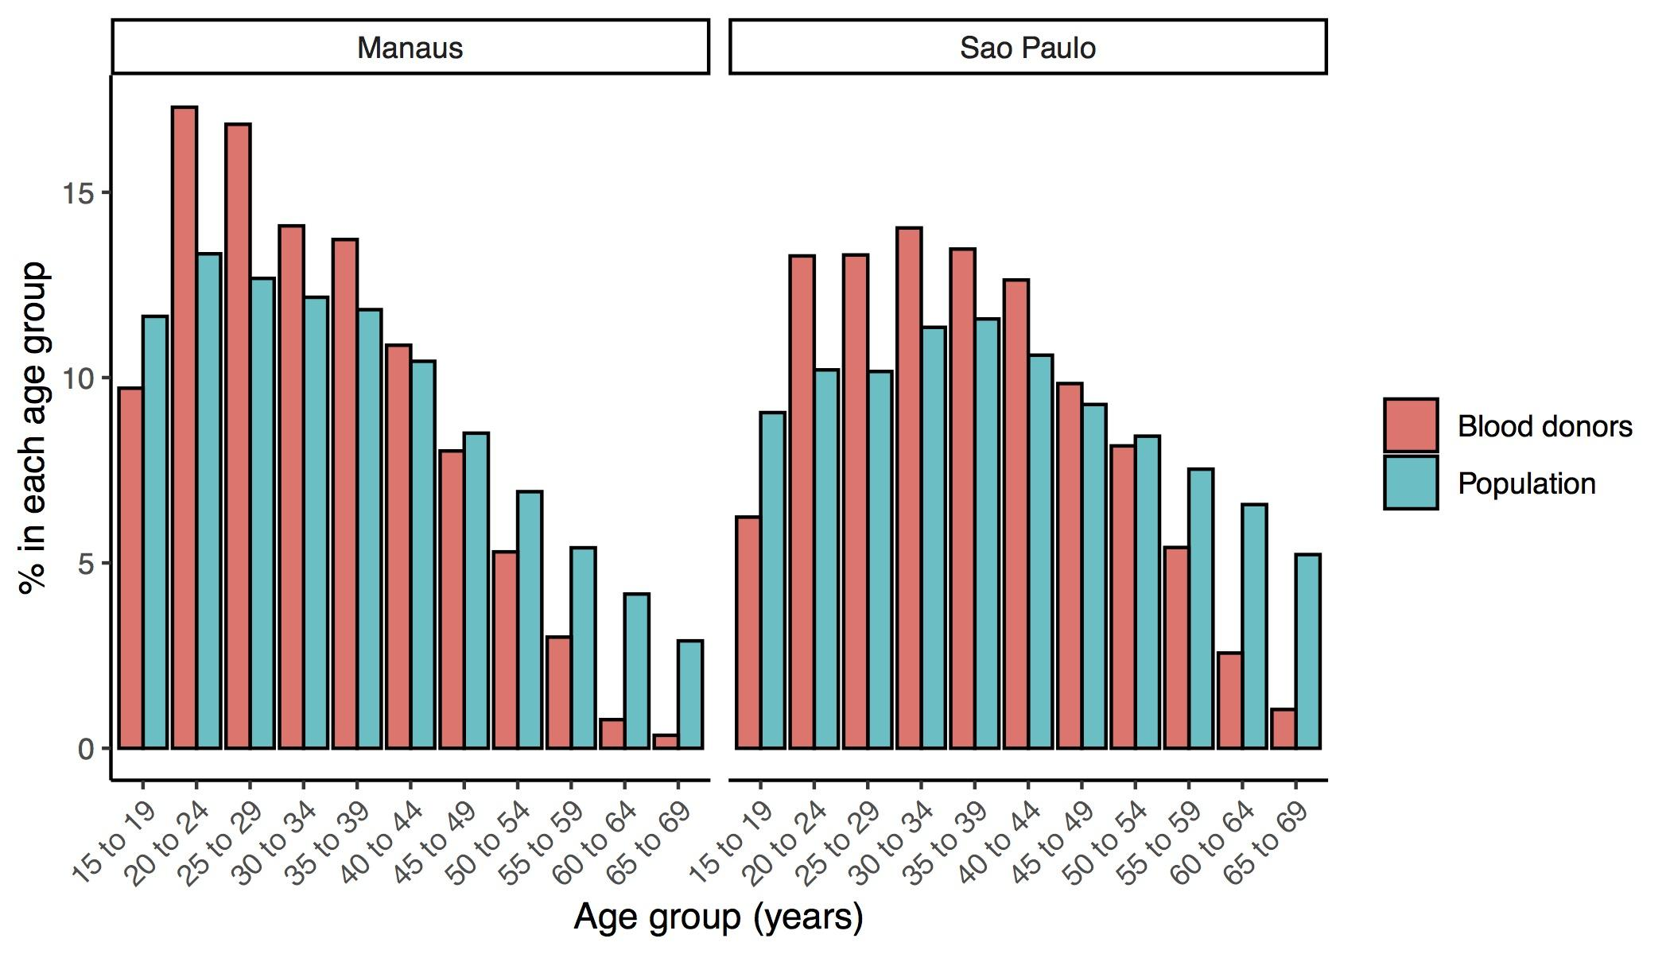

**Figure S1. Age distribution of blood donors and the underlying population in São Paulo and Manaus.** Comparison restricted to the age range that is eligible for blood donation.

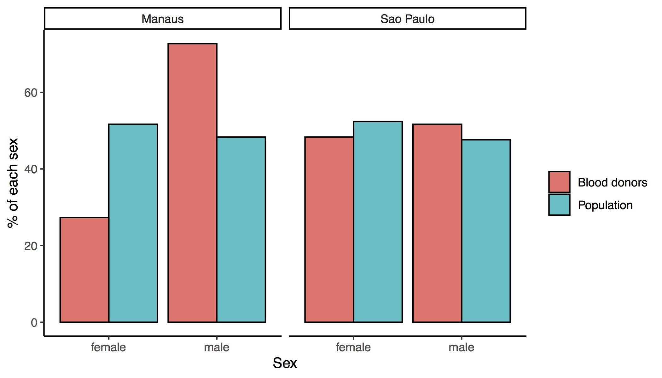

**Figure S2. Sex distribution of blood donors and the underlying population in São Paulo and Manaus.** Comparison restricted to the age range that is eligible for blood donation.

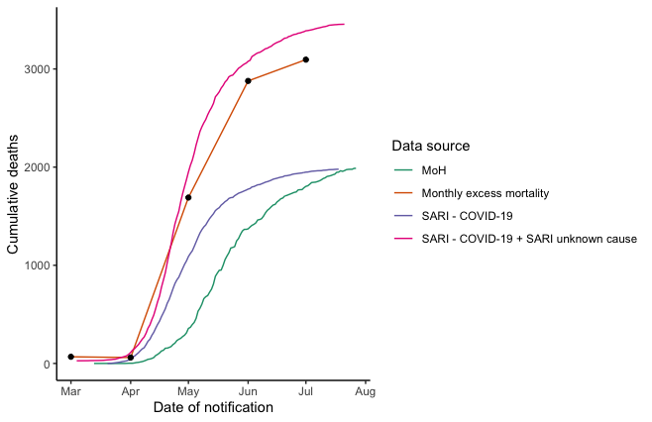

**Figure S3 Cumulative deaths in Manaus according to multiple data sources.** MoH – Ministry of Health official data source (<https://covid.saude.gov.br/>); excess mortality was calculated as the difference in total total monthly deaths between 2020 and 2019 (data from <https://transparencia.registrocivil.org.br/cartorios>); Severe acute respiratory syndrome (SARI – SIVEP-Gripe https://opendatasus.saude.gov.br/dataset/bd-srag-2020) .

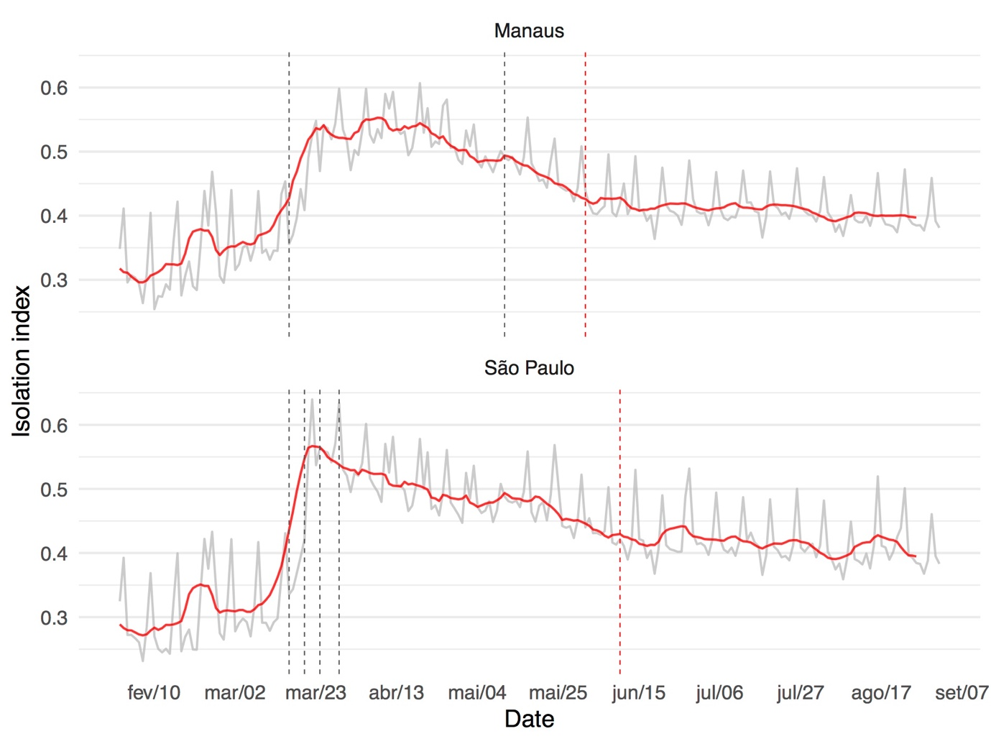

**Figure S4** Isolation index calculated from cell phone data (<https://mapabrasileirodacovid.inloco.com.br/pt/>) for São Paulo and Manaus.

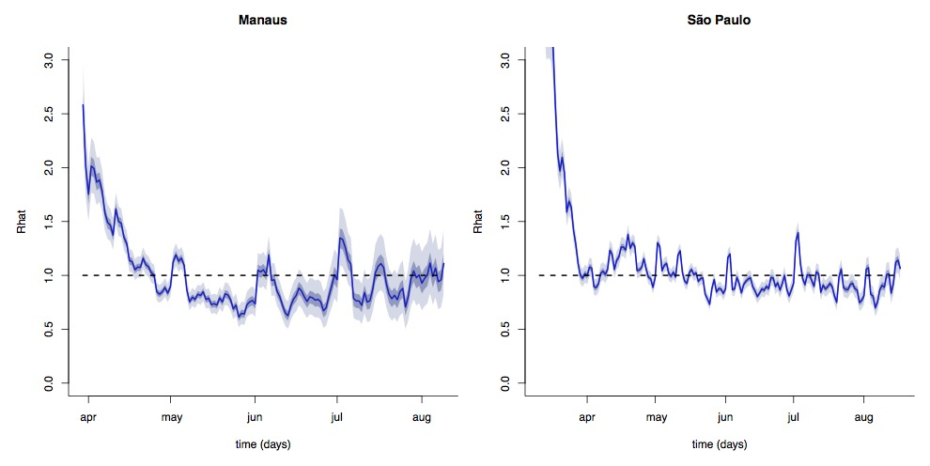

**Figure S5 Effective reproduction number for São Paulo and Manaus**. Calculated using daily severe acute respiratory syndrome cases with confirmed COVID-19.